Olympic list: clout city
By John Pletz, Crains Chicago Business – March 2, 2009
A newly released list of donors to Chicago's Olympics bid includes many with more than just a rooting interest in the city's quest for the games.
Along with the usual businesses and civic luminaries are city contractors and other contributors with business reasons to stay on the good side of Mayor Richard M. Daley, who has personally led Chicago's three-year pursuit of the games.
"This is another way to be noticed by the mayor and other key decision-makers involved in city contracts," says Dick Simpson, a professor at the University of Illinois at Chicago and a former alderman. "If you're a major corporation in town, this is a list you want to be on."
The Chicago 2016 committee raised $50 million to fund the city's bid for the games and $8 million to launch a non-profit youth sports foundation. The city's final bid documents, which were submitted Feb. 12 to the International Olympic Committee, included a list of 353 donors that gave at levels from $5,000 to more than $1 million. Nearly half gave more than $100,000.
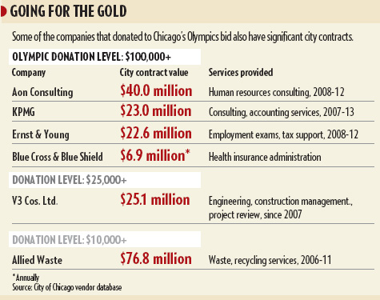
"The people and businesses in Chicago have rallied behind what the Olympics could do for the city. They have supported us on that fact and the long-term positive impact the games would have for generations of Chicagoans," a Chicago 2016 spokesman says.
To be sure, it appears that few prominent Chicago businesses didn't donate. And many — if not most — of the companies, foundations, wealthy families and civic leaders on the 2016 list also have supported projects such as Millennium Park. The list includes universities, banks, major law firms and media outlets, including Crain's.
But also listed are companies that benefit from maintaining a good relationship with Mr. Daley, that do significant business with City Hall or that could benefit directly from the games. The companies say their business with City Hall was not a factor in their donations.
Steelmaker A. Finkl & Sons Co. has sought assistance in moving its factory to the South Side from Lincoln Park. "The company has always supported civic and charitable efforts," a spokeswoman says.
Among the city contractors on the list were accounting and consulting firms KPMG and Ernst & Young LLP, both of which recently signed multiyear vendor contracts worth $20 million or more, according to city records. "It's civic pride," KPMG says. "What's good for Chicago is good for us, for everybody."
Ernst & Young did not return calls seeking comment.
The city's big construction companies are well-represented on the list, as are real estate developers, labor unions and engineering and architecture firms. The Olympics would bring $1.5 billion in construction projects, such as the Olympic Village and stadium, at a time when the commercial building pipeline is drying up.
"It's a combination of we're proud citizens of Chicago and think it's great for the city," says Patrick Kennedy, president of Woodridge-based V3 Cos. Ltd., a construction-management and engineering firm that has done about $25 million in work for the city in the past six years. "Certainly, if the Olympics come to Chicago, it would be good for the economy and the region."
Many of the companies on the list would stand to benefit from any economic boost the Olympics would bring to Chicago. United Airlines, a longtime sponsor of the U.S. Olympic Committee, gave more than $100,000 to Chicago's bid. It also received incentives in moving its headquarters downtown two years ago and is involved in intense negotiations over the expansion of city-controlled O'Hare International Airport.
In a statement, United says, "Having the 2016 Olympics in Chicago is a good opportunity for our community and our business."
Others on the list are closely linked to the Olympics bid. Aon Consulting, a unit of insurance company Aon Corp., gave more than $100,000. Aon founder and former Chairman Patrick Ryan is CEO of Chicago 2016. "It's totally connected to Chicago and sport," an Aon spokesman says.
The hundred-grand club also includes accounting firm Deloitte LLP, whose local managing partner, Deb DeHaas, co-chairs the 2016 fundraising committee.
But those firms also do significant business with the city. Aon recently won a $40-million contract for employee-hiring tests, according to city records. Deloitte has done $15.1 million in auditing work for the city since 2003.
"We consider it to be our corporate responsibility to support and give back to our communities," Deloitte says in a statement.
"There is a public-private machine that runs things in Chicago, and you want to be part of that if you're a major company," Mr. Simpson says.

